What is the day today?

Day
Month
the

Yesterday
Tomorrow


Days
Monday
Tuesday
Wednesday
Thurday
Friday
Saturday
Sunday
Months
June
January
February
July
March
August
April
September
May
October
November
December

Numbers
1
2
2
1
6
3
4
5
3
7
8
9
0
Season
Autumn / fall
Winter
Spring
Summer
How is the weather like ?

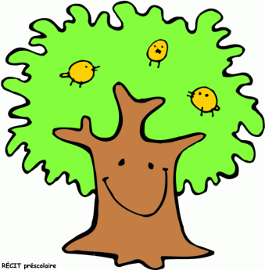

Yesterday
Season

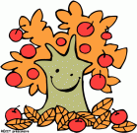
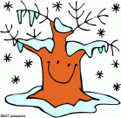

st
t
rd
t
Monday
Tuesday
Wednesday
Thursday
Friday
Saturday
Sunday
January
September
October
November
December
August
July
0
1
2
3
1
2
3
4
5
6
7
8
9

February

th
t
nd
t
March
August
September
October
November
April
autumn / fall
Winter
Spring
Summer

May

June

It’s sunny
It’s snowing
It’s cloudy
It’s windy
It’s raining
It’s foggy

